**Flop Donk Bet** (DK) **Flop Cbet-Fold Single Rsd Pot** (FCBvsR) **Flop Check-Raise OOP** (CR)

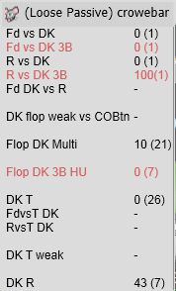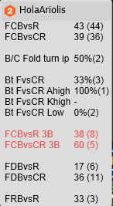 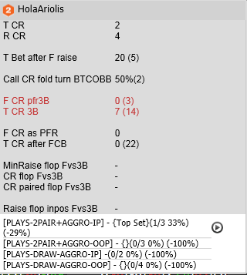

**River Bet** (BR) **WTSD%** (SD)

